1. Effective bid-ask spread

1) equal weighted effected bid-ask spread

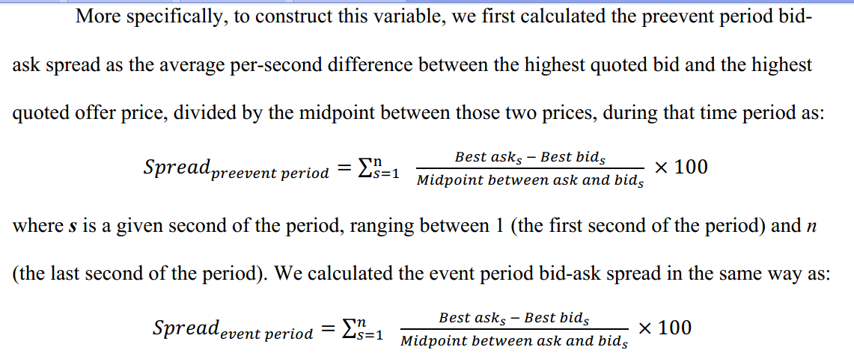

Reference:

Amiram, Dan, Edward Owens, and Oded Rozenbaum. "Do information releases increase or decrease information asymmetry? New evidence from analyst forecast announcements." Journal of Accounting and Economics 62.1 (2016): 121-138.

Blankespoor, Elizabeth, Gregory S. Miller, and Hal D. White. "The role of dissemination in market liquidity: Evidence from firms' use of Twitter™." *The Accounting Review* 89.1 (2014): 79-112.

2) dollar weighted effected bid-ask spread

Reference:

Goyenko, Ruslan Y., Craig W. Holden, and Charles A. Trzcinka. "Do liquidity measures measure liquidity?." *Journal of financial Economics* 92.2 (2009): 153-181.

Lee, Charles MC, and Edward M. Watts. "Tick size tolls: Can a trading slowdown improve earnings news discovery?." *The Accounting Review* 96.3 (2021): 373-401.

3) share weighted effected bid-ask spread

Not often

Goyenko, Ruslan Y., Craig W. Holden, and Charles A. Trzcinka. "Do liquidity measures measure liquidity?." *Journal of Financial Economics* 92.2 (2009): 153-181. Lee, Charles MC, and Edward

2. Trading Volume

3. Depth (absolute value and natural logarithm)

Economic Link with Liquidity: An increase (decrease) in quoted depth reflects a decrease (increase) in information asymmetry.

1) Daily dollar depth

Daily dollar depth is the daily average of each quote’s depth, calculated as the sum of the dollar offer size and the dollar bid size.

Reference:

Blankespoor, Elizabeth, Gregory S. Miller, and Hal D. White. "The role of dissemination in market liquidity: Evidence from firms' use of Twitter™." *The Accounting Review* 89.1 (2014): 79-112.

Bushee, Brian J., et al. "The role of the business press as an information intermediary." *Journal of accounting research* 48.1 (2010): 1-19.

2) Daily share depth

Daily dollar depth is the daily average of each quote’s depth, calculated as the sum of the share offer size and the share bid size.

Reference:

Coller, Maribeth, and Teri Lombardi Yohn. "Management forecasts and information asymmetry: An examination of bid-ask spreads." *Journal of accounting research* 35.2 (1997): 181-191.

Amiram, Dan, Edward Owens, and Oded Rozenbaum. "Do information releases increase or decrease information asymmetry? New evidence from analyst forecast announcements." Journal of Accounting and Economics 62.1 (2016): 121-138.

4. price impact (lower value, higher market liquidity)

Economic Link with Liquidity: An increase (decrease) in price impact reflects a increase (decrease) in information asymmetry.

Price impact:

The average transaction-based dollar price impact for all trades in firm *i*’s stock on day *d* (multiplied by 100).



5. Breath

1) the number of shareholders

2) The number of institutional shareholders

Reference:

Grullon, Gustavo, George Kanatas, and James P. Weston. "Advertising, breadth of ownership, and liquidity." The Review of Financial Studies 17.2 (2004): 439-461.

6. zero return (lower value, higher market liquidity)

7. trading costs (lower value, higher market liquidity)